# Running CSIRO Database on the RDF4J server with Tomcat

## Setup instructions

<http://docs.rdf4j.org/server-workbench-console/> - Overview of the entire process

<http://www.ntu.edu.sg/home/ehchua/programming/howto/tomcat_howto.html> – Install Tomcat

<https://docs.oracle.com/cd/E19182-01/820-7851/inst_cli_jdk_javahome_t/> - Install Java Development Kit (JDK) and set JAVA_HOME

<https://www.baeldung.com/tomcat-deploy-war> - Deploy RDF4J War files to Tomcat

<http://docs.rdf4j.org/server-workbench-console/#_modifying_the_data_contents_of_a_repository> – Add CSIRO data

## Apache Tomcat Running

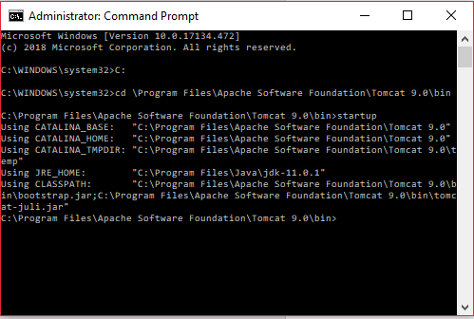

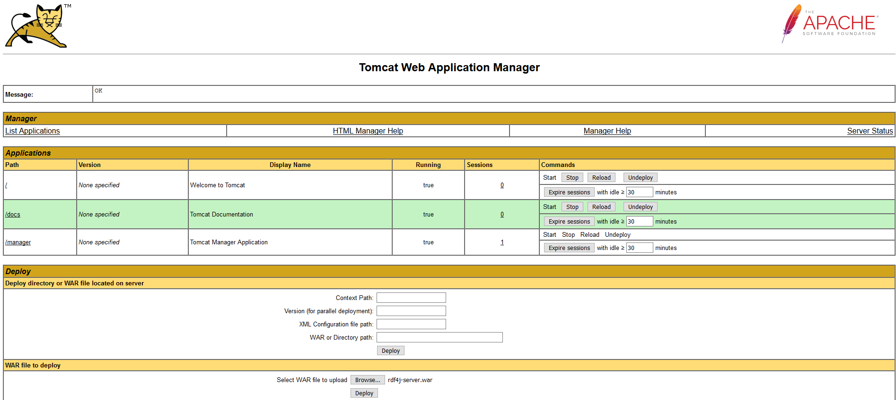

## RDF4J War files deployed and running

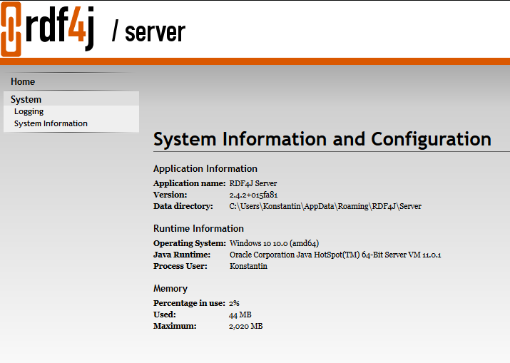

## CSIRO data uploaded, queries working

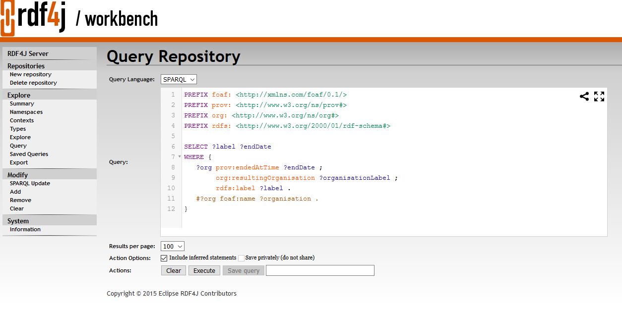

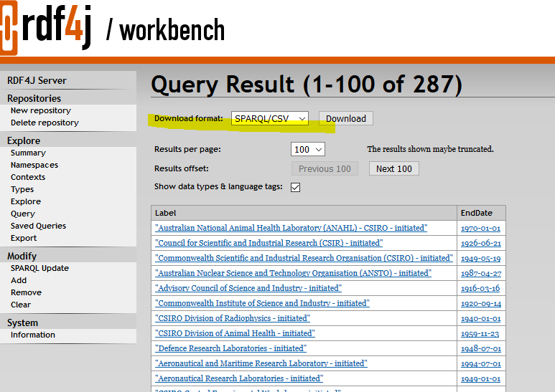

# REST API capability – to explore at a later point in time

http://docs.rdf4j.org/rest-api/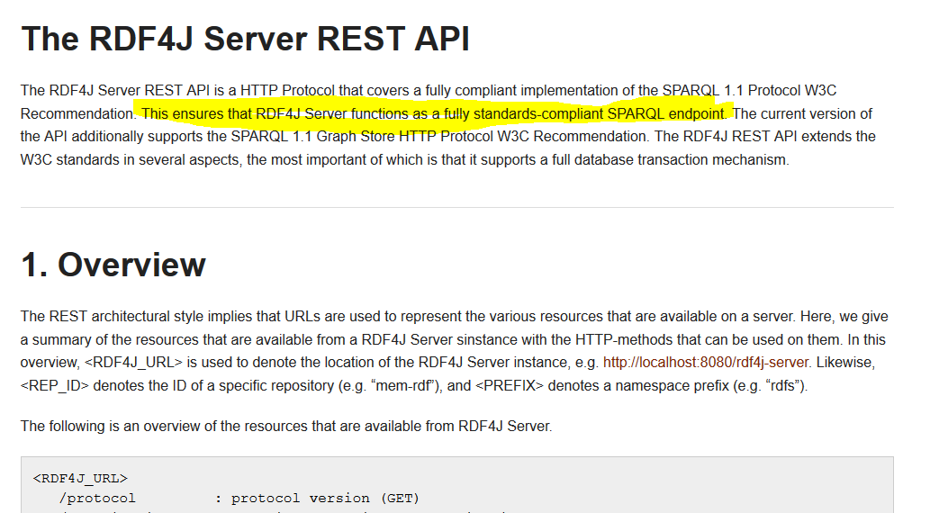

<http://docs.rdf4j.org/rest-api/>